 | SCARBOROUGH: MARCH 2025  FEATURE OF THE MONTH: WINTER MENU SPEcIALS  AREAS BEST HAPPY HOUR: Mon-Fri 3pm-6pm $5 SELECT Crafts & FOOD
SUNDAY | MONDAY | TUESDAY | WEDNESDAY | THURSDAY | FRIDAY | SATURDAY
 | 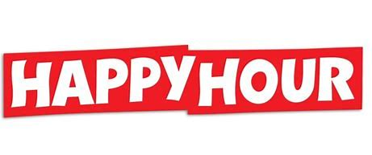  MON-FRI 3-6p  $5 SELECT BEERS  $5 FOOD SPEC. |  |  |  |  | 1  SPORTS SATURDAY  LIVE MUSIC 6pm  2 For Jackson
2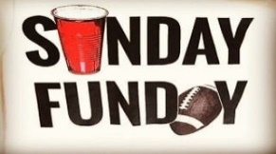   MUG CLUB | 3 MONDAY  $6 MARGARITAS 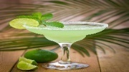  ½ PRICE TACOS | 4    $4 LADIES WINE  w/food purchase | 5    7pm  SHIPYARD /SURFSIDE  SPECIALS | 6    TALLS FOR SMALLS | 7    $5 BEERS/FOOD  FRIDAY KARAOKE | 8 5th ANNIVBERSARY PARTY  SPORTS SATURDAY  LIVE MUSIC 6pm  Mad hatter
9   MUG CLUB | 10 MONDAY  $6 MARGARITAS 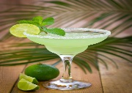  ½ PRICE TACOS | 11  $4 LADIES WINE  w/food purchase | 12    7pm  SHIPYARD /SURFSIDE  SPECIALS | 13  TALLS FOR SMALLS | 14    $5 BEERS/FOOD  FRIDAY KARAOKE  7pm | 15  SPORTS SATURDAY
16  MUG CLUB | 17 ST PATS MONDAY  $6 MARGARITAS  ½ PRICE TACOS | 18  $4 LADIES WINE  w/food purchase | 19  7pm  SHIPYARD /SURFSIDE  SPECIALS | 20 MARCH  MADNESS  w/ Chris Skidgel  TALLS FOR SMALLS | 21 MARCH  MADNESS    $5 BEERS/FOOD  FRIDAY KARAOKE | 22 MARCH  MADNESS  SPORTS SATURDAY  LIVE MUSIC 6pm  tUMBLEDOWN SAINTS
23/30 MARCH  MADNESS  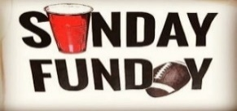  MUG CLUB | 24/31 MONDAY  $6 MARGARITAS  ½ PRICE TACOS | 25  $4 LADIES WINE  w/food purchase | 26  7pm  SHIPYARD /SURFSIDE  SPECIALS | 27 MARCH  MADNESS  w/ Chris Skidgel  TALLS FOR SMALLS | 28 MARCH  MADNESS  $5 BEERS/FOOD  FRIDAY KARAOKE | 29 MARCH  MADNESS  SPORTS SATURDAY  

