 | julY 2024 : ENTERTAINMENT CALENDAR BIDDEFORD  FEATURE OF THE MONTH: CHECK OUT OUR SUMMER MENU SPECIALS  BEST HAPPY HOUR IN TOWN M-F 3pm-6pm: SELECT CRAFTS $4 & $5 FOOD
 | - MONDAY  $6 MARGARITAS   | 2 NO TRIVIA  7pm  SHIP & SAM SPEC. | 3    1/2 PRICE TACOS  6pm-cl | 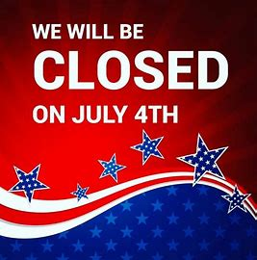 | 5 FRIDAY    * LIVE MUSIC*  Mike & PAul  7pm  RED SOX/Yankees | 6  SPORTS SATURDAY  RED SOX/Yankees
7     MUG CLUB  RED SOX/Yankees | 8  $6 MARGARITAS | 9    7pm  SHIP & SAM SPEC. | 10  1/2 PRICE TACOS  6pm-cl | 11  TALLS FOR SMALLS   | 12    * LIVE MUSIC*  Cali crush  7pm | 13  SPORTS SATURDAY
14  MUG CLUB | 15 $6 MARGARITAS | 16 $500 TEAM TRIVIA  7pm  SHIP & SAM SPEC, | 17  1/2 PRICE TACOS  6pm-cl | 18  TALLS FOR SMALLS | 19    * LIVE MUSIC*  Don mills  7pm | 20  SPORTS SATURDAY
21  MUG CLUB | 12 $6  MARGARITAS | 23 $500 TEAM TRIVIA    7pm  SHIP & SAM SPEC. | 24  1/2 PRICE TACOS  6pm-cl | 25  TALLS FOR SMALLS | 26  * LIVE MUSIC*  Rexy dinosaur  7pm  RED SOX/Yankees | 27  SPORTS SATURDAY  OLYMPICS  RED SOX/Yankees
28  MUG CLUB  RED SOX/Yankees | 29 $6  MARGARITAS | 30 $500 TEAM TRIVIA  7pm  SHIP & SAM SPEC, | 31  1/2 PRICE TACOS  6pm-cl |  |  MON-FRI  3pm-6pm

