 | march 2025 : ENTERTAINMENT CALENDAR BIDDEFORD  FEATURE: MARCH MADNESS  BEST HAPPY HOUR IN TOWN M-F 3pm-6pm: SELECT CRAFTS $4 & $5 FOOD
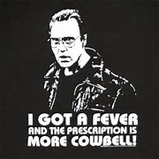 |   MON-FRI  3pm-6pm |  |  |  |  | 1  SPORTS SATURDAY  * LIVE MUSIC*  SIERRA HARRIS  630pm
2  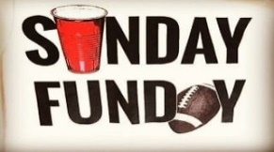   MUG CLUB | 3 MONDAY  $6 Margaritas  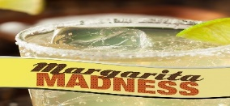 | 4 CASH TRIVIA    7pm  SHIPYARD /SURFSIDE  SPECIALS | 5 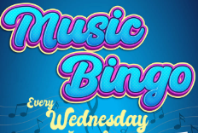  WEDNESDAY 6-cl  MUSIC BINGO | 6 TALLS FOR SMALLS    COUNTRY NIGHT  LIVE MUSIC 6-9pm  TOBY MCCaLLISTER | 7    * LIVE MUSIC*  MIKE & pAUL  630pm | 8  SPORTS SATURDAY  COLLEGE FOOTBALL  * LIVE MUSIC*  JUSTIN CARVER  630pm
9  MUG CLUB | 10 MONDAY  $6 Margaritas  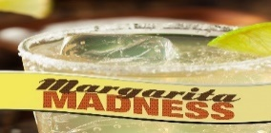 | 11 CASH TRIVIA  7pm  SHIPYARD /SURFSIDE  SPECIALS | 12  WEDNESDAY 6-cl  MUSIC BINGO | 13 TALLS FOR SMALLS  COUNTRY NIGHT  LIVE MUSIC 6-9pm  Bryan frates | 14    * LIVE MUSIC*  PIANO NITE  w/ CARMINE | 15  SPORTS SATURDAY  * LIVE MUSIC*  ALEX ROY  630pm
16 RESTAURANT week  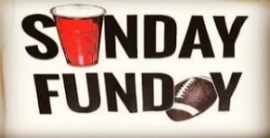  MUG CLUB | 17 RESTAURANT week  MONDAY  $6 Margaritas  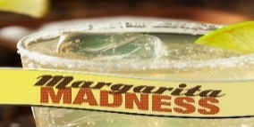 | 18 CASH TRIVIA    7pm  SHIPYARD /SURFSIDE  SPECIALS | 19 RESTAURANT week  WEDNESDAY 6-cl  MUSIC BINGO | 20 RESTAURANT week TALLS FOR SMALLS  COUNTRY NIGHT  LIVE MUSIC 6-9pm  Chase jobe | 21 RESTAURANT week  * LIVE MUSIC*  Quiot riot act  630pm | 22 RESTAURANT week  SPORTS SATURDAY  * LIVE MUSIC*  ROBERT FOWLER  “only HOPE BAND”  630pm
23/30 | 24/31 MONDAY  $6 Margaritas  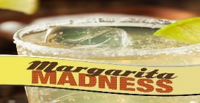 | 25 CASH TRIVIA  7pm  SHIPYARD /SURFSIDE  SPECIALS | 26  WEDNESDAY 6-cl  MUSIC BINGO | 27 TALLS FOR SMALLS  COUNTRY NIGHT  LIVE MUSIC 6-9pm  KRIS HYPE | 28  * LIVE MUSIC*  SIERRA HARRIS  630pm | 29  SPORTS SATURDAY  * LIVE MUSIC*  XANDER NELSON  630pm

